Price List |  | 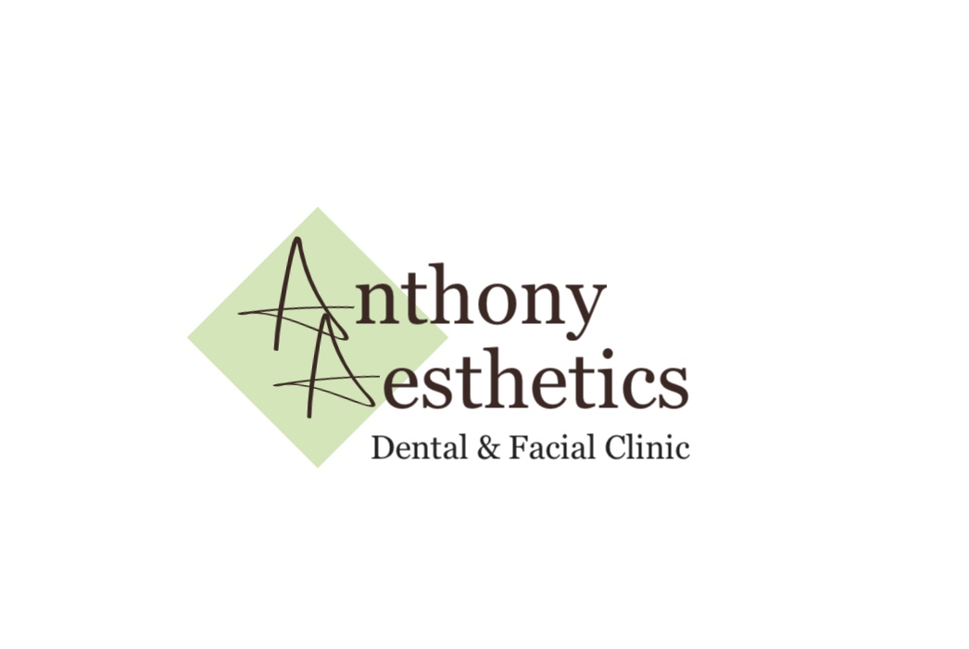

wrinkle-reducing  injections  Wrink | 1 Area | 2 Areas | 3 areas

Upper face |  | £100 | £155 | £210
Brow lift |  | £75
Lip lines |  | £75
Marionette lines |  | £100
Hyperhydrosis (armpit sweating) |  | £350

Fillers (TEOXANE)  (teoxane) | 1ml | 2 ml | 3 ml

Cheek filler | £250 £400 | £550
Jawline filler | £250 £400 | £550
Chin filler | £250 £400
Nose-Mouth lines | £220 £380
Marionette lines | £220 £380
Lip lines | £200 £360
Lip filler  (Product Dependent)  Tear Trough | £200/ £220  £185 (0.7ml)  £350
 | 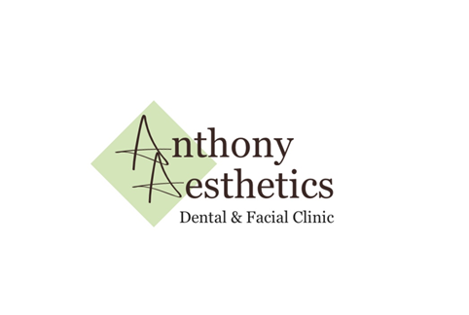

Redensity 1  Skin Boosters  Wrink | 1st session | 2nd session | 3rd session | Total  Course

Teoxane 1ml Redensity 1 |  |  | £150 £150 | £100 | £400
Teoxane 2ml (face & neck) |  |  | £250 £200 | £200 | £650
Teoxane 3ml Redensity 1 |  |  | £300 £250 | £200 | £750
Teoxane RHA1- fine lines Touch up |  |  | £150
 |  |  |  | Skin cosmeceuticals are also available on prescription with upto 30% off the rrp. products are available for all skin types, to help hydrate and rejuvenate, or treat skin concerns such as acne, enlarge pores, pigmentation and fine lines and wrinkles. Contact me to find out more or book a skin consultation. A range of skin peels are also available, from an instant glow to a deep retinol peel. for pca skin peel prices see below. these can be customised to your skin needs.

Pca sKIN TREATMENTS  Wrink | 1ST SESSION | 2nd session
Retinol 4% peel | £120 £100
Retinol 6% peel | £120 £100
Perfecting peel | £85 £75
Perfecting peel &  Retinol boost | £100 £80
Oxygenating Trio/  Red carpet facial | £75 £60
Ultimate Peel  (Perfecting peel &  6% Pure Retinol) | £135 £120

